The Chain Rule

**Simple Definition**: The **Chain Rule** is a method in calculus used to differentiate a function that is made up of one function inside another (a composite function). It allows us to break things down step by step. Here's how it works in the simplest way:

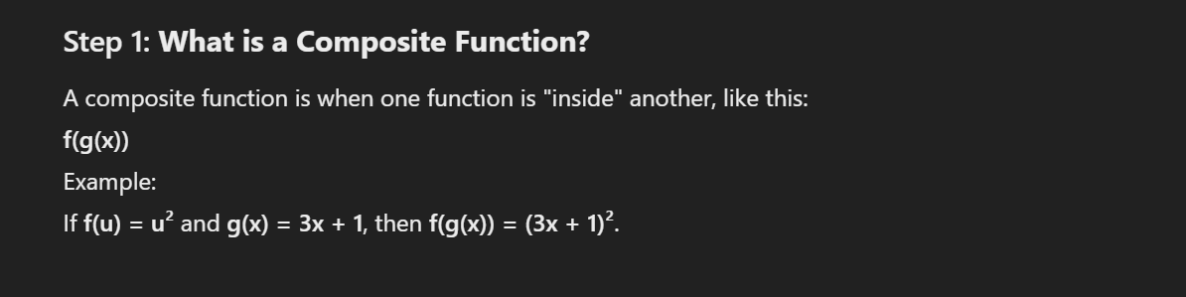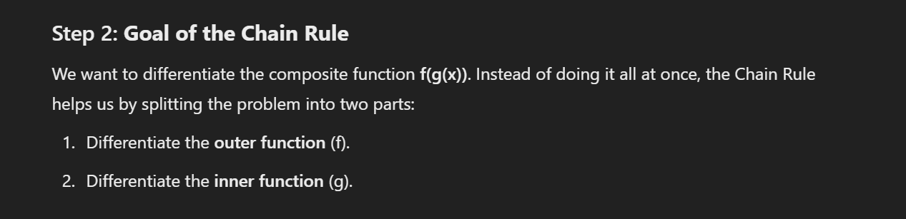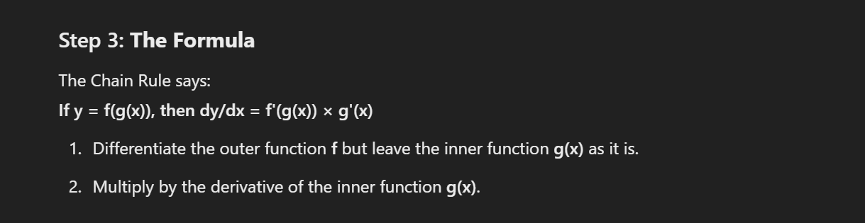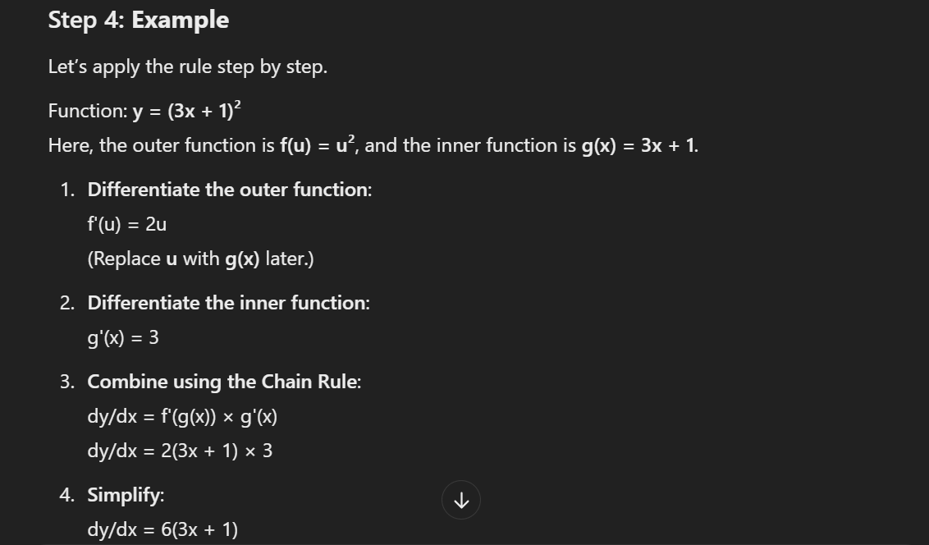

**Example:**   
 Find 𝑑𝑤/𝑑𝑡 if 𝑤 = tan 𝑥 and 𝑥 = 4𝑡^3 + t

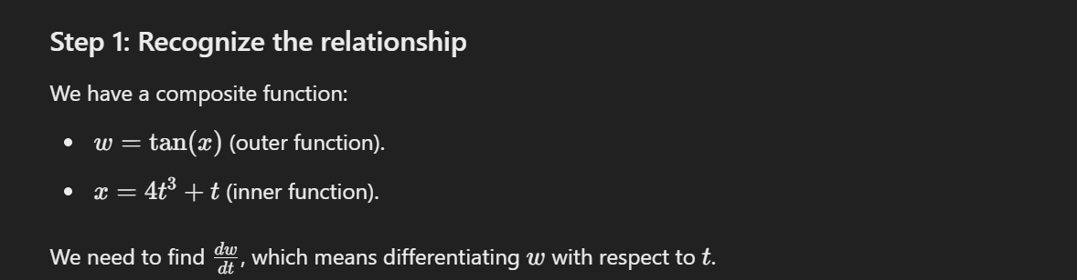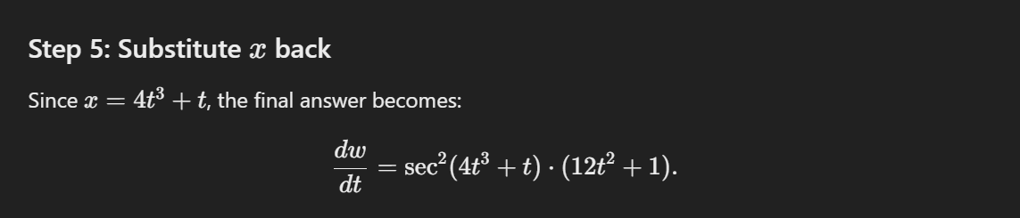

Now look, the above may look confusing, am I right? But below thing might help you have “my” kind of confusion.

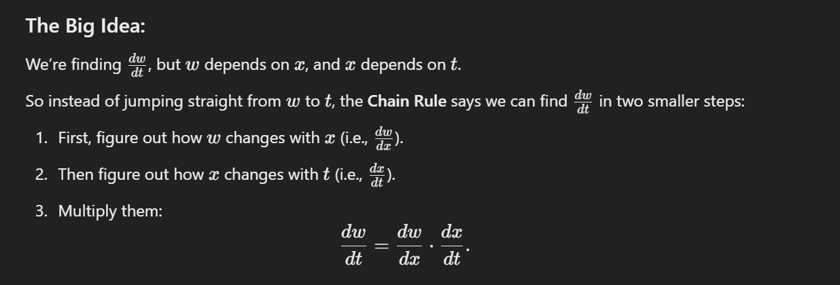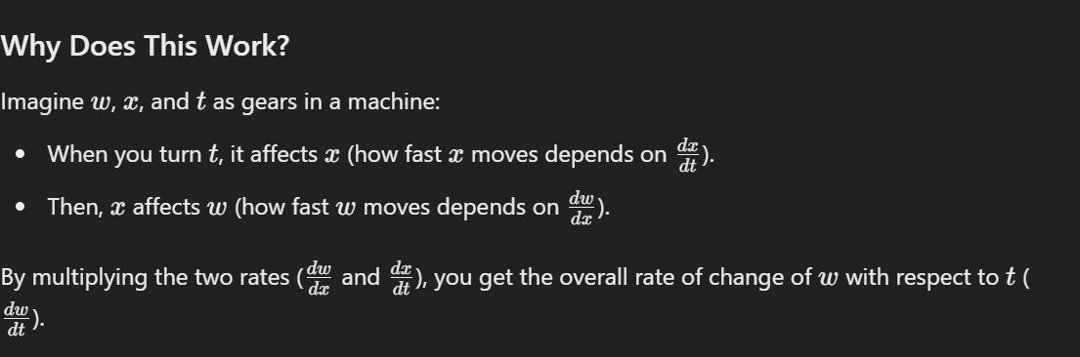

Step 2 explanation

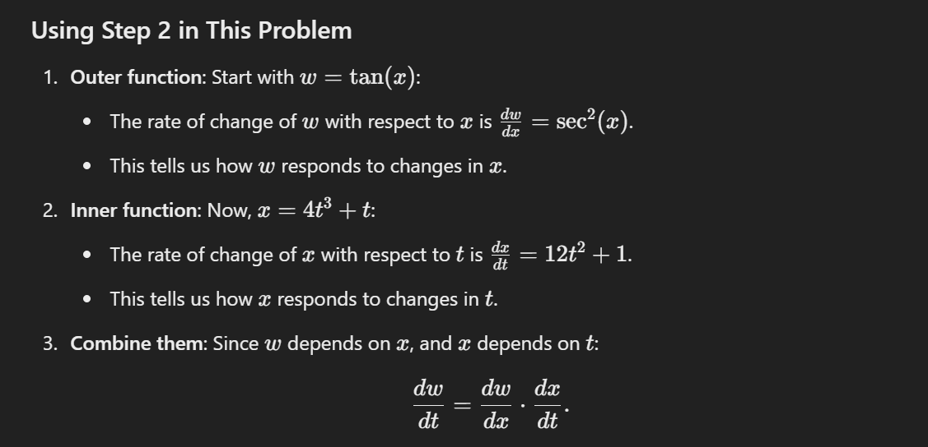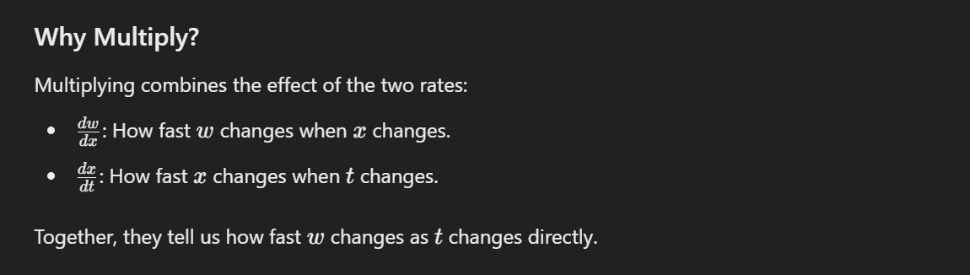

ight